* Use SQLMap to check the SQL injection vulnerability of <http://testphp.vulnweb.com/>.

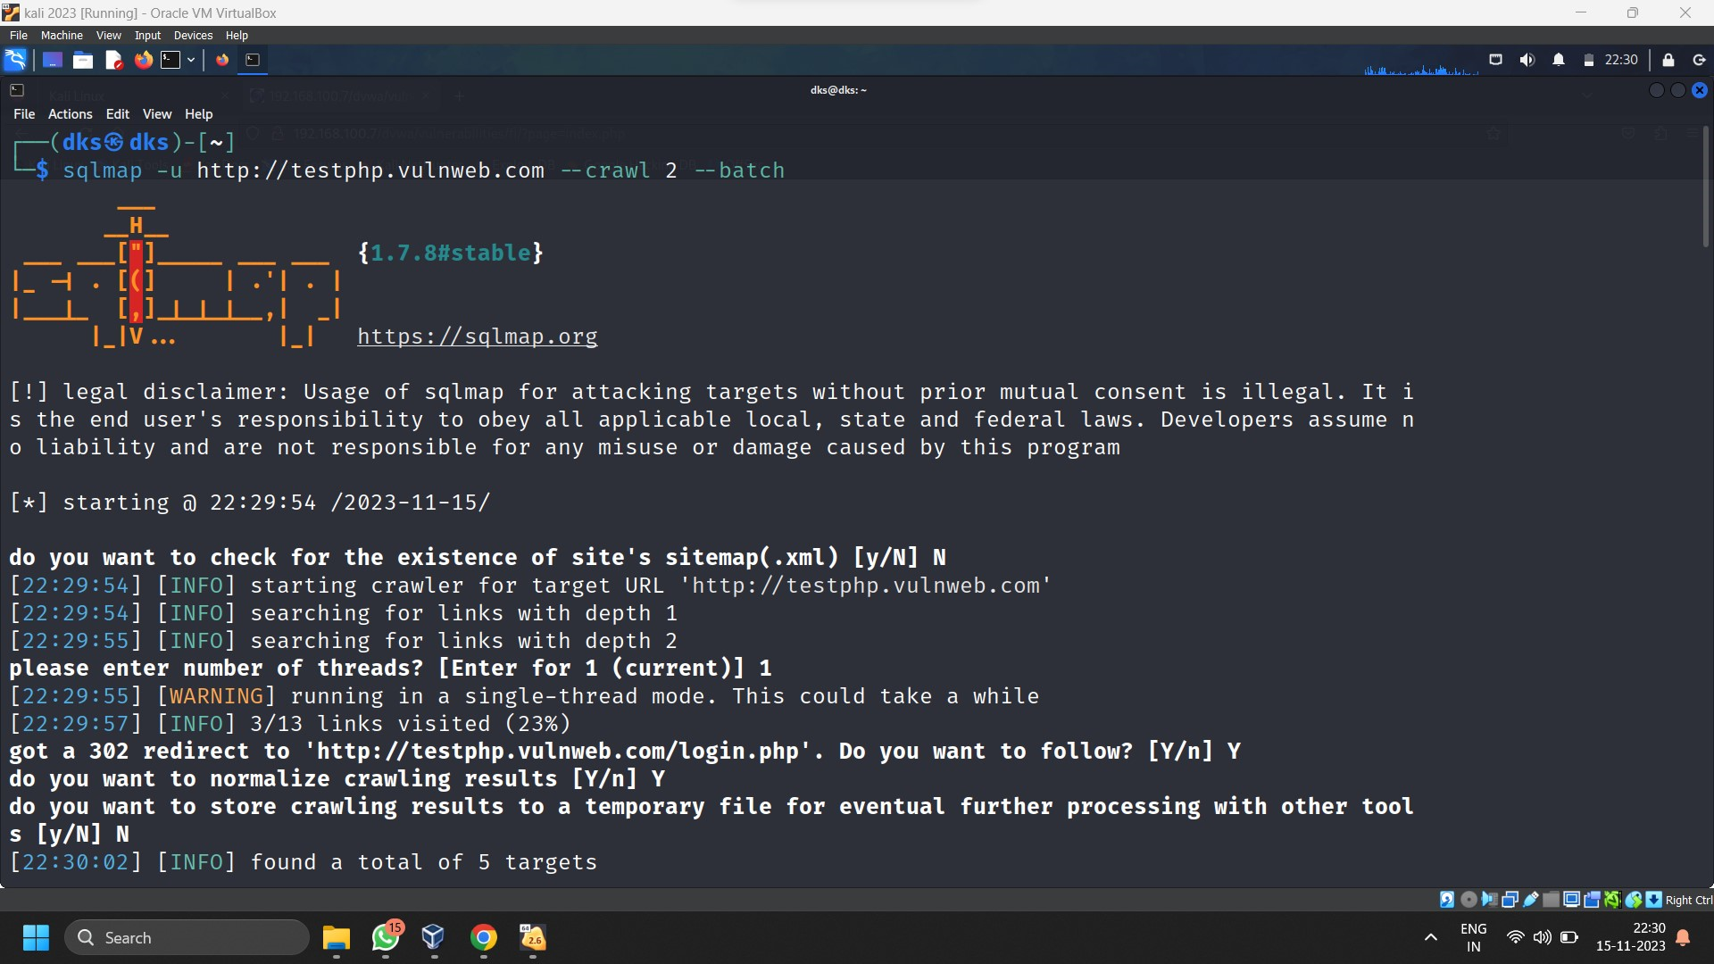

* Use SQLMap to check the SQL injection vulnerability of your OWASP Server.

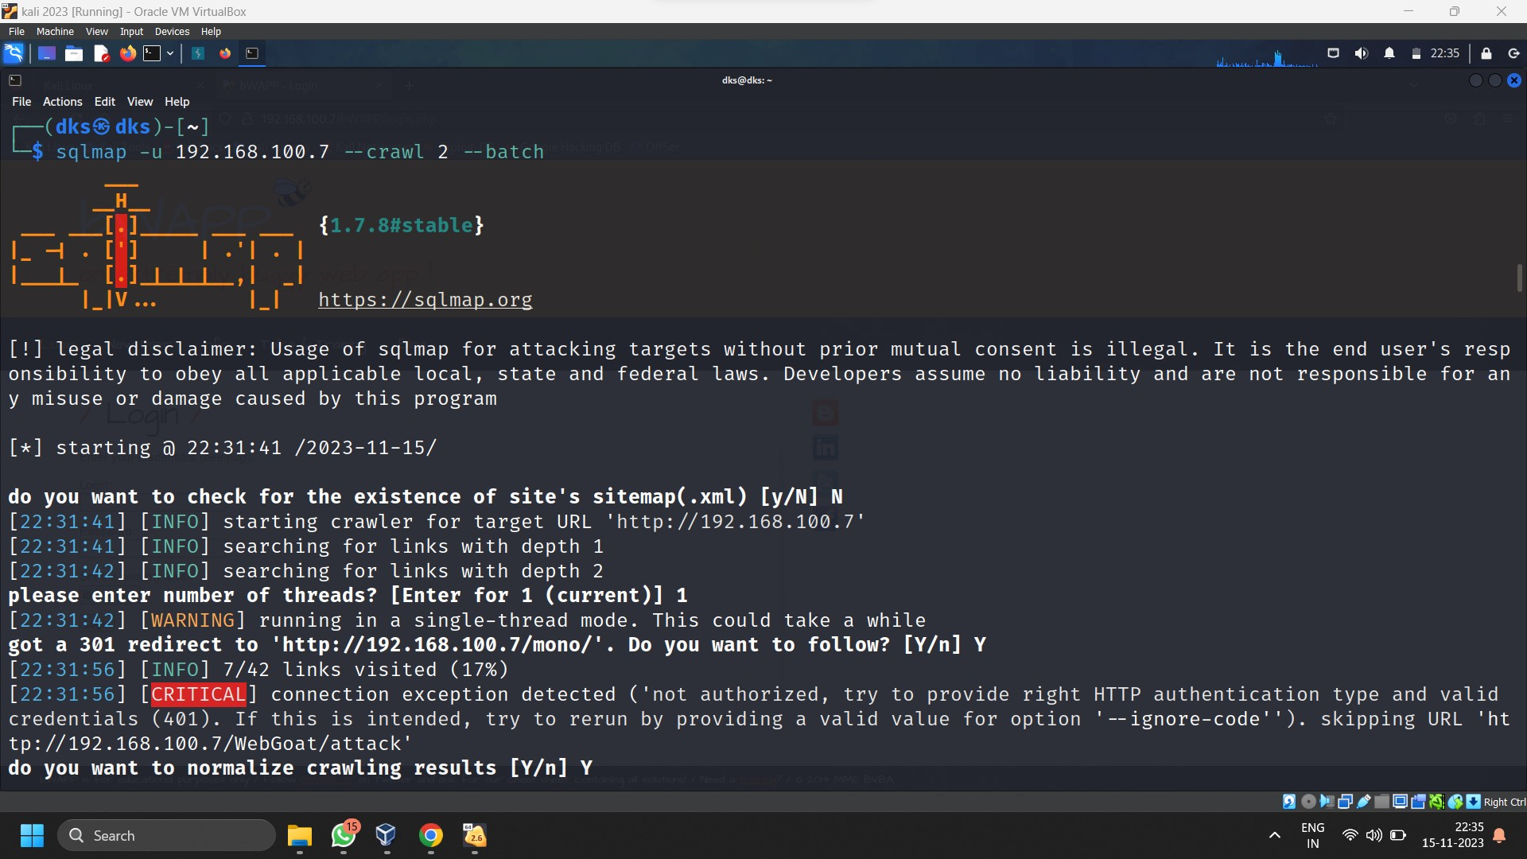

* Use Burp Suite to practice different attack types with OWASP bWAPP application

